WEB Project :
Project Name – Team 9
Team members:
- Mitra
- Neky
- Tian
Project Description:
Design the website for selling Products.

Table of contents:
- Features
- Database Tables
- ER Diagram
- Created Form
- Created Tables
- Project Progress
Features:
User Registration
User Login System
Product Management-CRUD

User Registration:
Description:
Allow new users to create an account
Includes:
- Form validation
- Password Hashing
- Email uniqueness check
- GitHub Link:
https://github.com/mitradehghani/register.php
- Live Link (shell.hamk.fi):
https://shell.hamk.fi/amk1005936 /project/register.php

User login System:
Description:
Allows registered user to log in securely
Include:
- Password verification
- Session handling
- Logout functionality

GitHub Link:
https://github.com/mitradehghani/login.php
Live Link (shell.hamk.fi):
https://shell.hamk.fi/amk1005936 /project/login.php
Product Management:
Description:
Admin users can create, read, update, and delete products.
Includes:
- Add new product
- Edit product
- Delete product
- View product list
GitHub Link:
https://github.com/your-repo/products.php
Live Link (shell.hamk.fi):
https://shell.hamk.fi/amk100/project/products.php
Database Tables:
- Users
- Products
- Orders
ER Diagram:
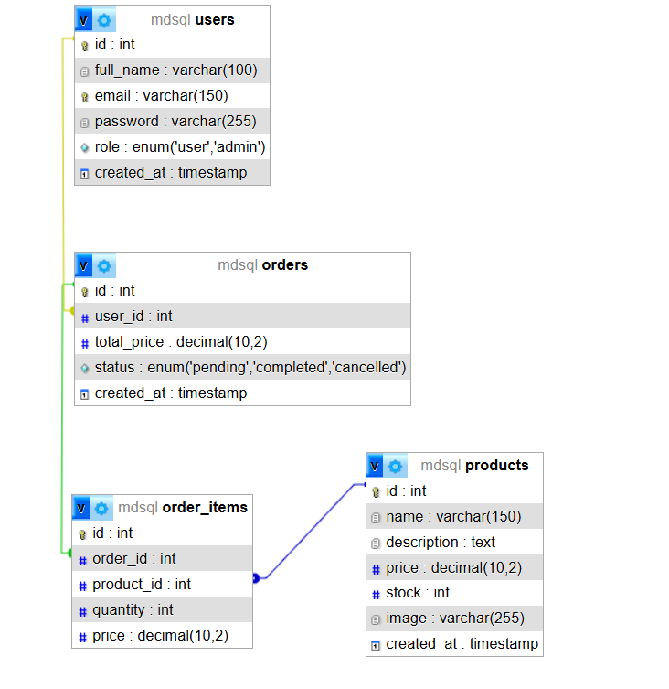

Created Forms
1️⃣ Registration Form
Created By: Mitra
File: register.php
GitHub: https://github.com/your-repo/register.php
Live: https://shell.hamk.fi/amk1005936 /project/register.php
Validations Applied:
- Required fields check
- Email format validation
- Password length check
- Password confirmation match
2️⃣ Login Form
Created By: Mitra
File: login.php
GitHub: https://github.com/your-repo/login.php
Live: https://shell.hamk.fi/amk1005936 /project/login.php
Validations Applied:
- Required fields
- Password verification
- Session start validation
3️⃣ Product Form
Created By: Tian
File: add_product.php
GitHub: https://github.com/your-repo/add_product.php
Live: https://shell.hamk.fi/amk1005936/project/add_product.php
Validations Applied:
- Required fields
- Price must be numeric
- Image file type validation

Date | Task | Status | Responsible
10.02.2026 | Project setup | ✅ Completed | Team
14.02.2026 | Database created | ✅ Completed | Mitra
15.02.2026 | Registration form | ⏳ In Progress | Mitra
16.02.2026 | Login system | ⬜ Not Started | Mitra
 | Add product |  | Tian

